Best Buddies Standardized
eNewsletter Template
DOWNLOAD THIS DOCUMENT BEFORE CUSTOMIZING
To maintain org-wide consistency in regards to sharing stories of our mission impact, our Best Buddies Newsletter template is specifically and strategically built to share concise mission-focused storytelling sections along with clear calls to action buttons. This newsletter template is designed to provide clear expectations for staff to help streamline and simplify the gathering and sharing of impactful mission focused newsletter content.
For org-wide brand and communication consistency, Best Buddies newsletters are to feature the following four sections and should be no more than 400 words:
Intro: (15-45 words) – REQUIRED SECTION
- Short intro message to say hello and summarize what’s included this month’s communication.
In the Spotlight: (75 to 150 words) – OPTIONAL SECTION
- This optional section gives your state the flexibility to showcase whatever is most urgent, timely or inspiring this month. This could be a new program launch, an awareness campaign, an opportunity to get involved, etc.
Featured Participant: (75 to 150 words) – REQUIRED SECTION
- Let's celebrate our amazing participants! Share their stories and show how our programs made a difference in their lives. This can be someone with or without a disability.
Mission Moment: (75 to 150 words) – REQUIRED SECTION
- Bigger picture time! Highlight the positive impact our programs have on the community overall. New projects, program expansion, event highlights, or other touching stories – anything that shows our mission in action.
Upcoming Events: (No more than 50 words) – OPTIONAL SECTION
- Give 'em a taste of the fun stuff! List a few exciting events and include a link to your state's events page for the full scoop. If you don't have any events in a given month, you can use this section to promote volunteer or other opportunities.
Keep it short and sweet. We want quality stories with a punch, followed by clear calls to action. Remember, most readers are checking this out on their phones, so let's save 'em some thumb-scrolling!
The ultimate goal is to encourage readers to click on calls to action, which means providing just enough information to pique their interest. For further email examples, image resources, and content tips, check out the Email Teams Wiki and explore the Email Resources document.
Image files: When submitting your tickets, please separately attach the original image files of any photos you have added below. The preferred image sizes for email images/graphics is 1200x630.

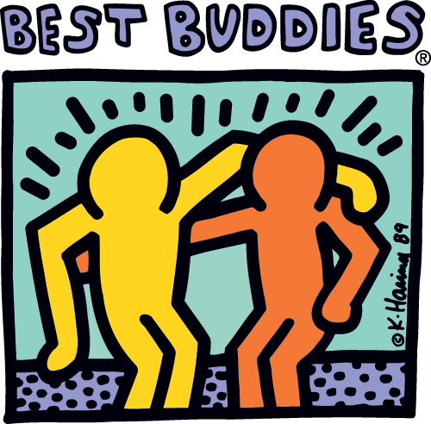
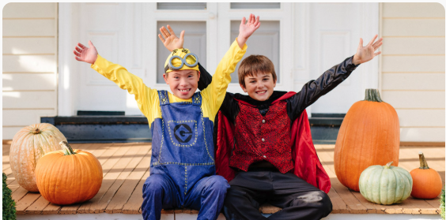
“State Name” Newsletter
(15- 40 words) This month we're thrilled to introduce you to the incredible Alex Green, a Best Buddies Ambassador and trailblazer in the IDD community. We will also showcase the upcoming Best Buddies Leadership Conference and additional activities for your participation.
In the Spotlight
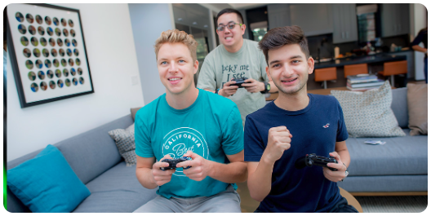
Subtitle Heading
(75 - 150 words) This optional section gives your state the flexibility to showcase whatever is most urgent, timely or inspiring this month. This could be a new program launch, an awareness campaign, an opportunity to get involved, etc.
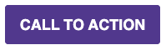
(Button Text = Learn More | Link = https://www.bestbuddies.org/global-ambassadors/ )
Featured Participant
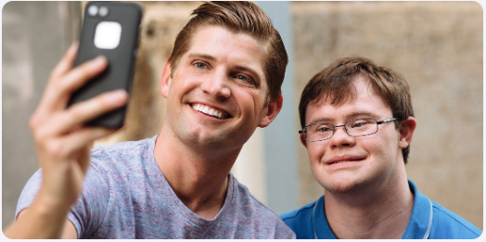
Meet Mike
(75 - 150 words) M Alex is a 27-year-old with a passion for cooking, comedy movies, and football. As a Best Buddies Ambassador, Axel has delivered speeches at the Miami Gala, and a University of Miami football game, and the United Nations on behalf of his peers. He loves working with children, and has been an aide and mentor at various organizations.
In 2024, he won Best Buddies in Florida's Champion of the Year - an honor for his outstanding fundraising efforts to support Best Buddies programs. Alex also made history by being the man with Down syndrome to give an address to the Florida State Senate!
(Button Text = Meet more Ambassadors | Link = https://www.bestbuddies.org/global-ambassadors/ )

Mission Moment
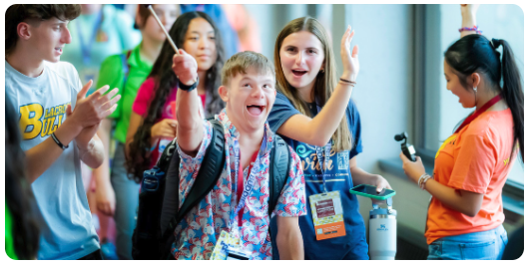
Inspiring Community Leaders
(75 - 150 words) This July, 47 student leaders from our state will be attending the annual Best Buddies Leadership Conference (BBLC) - a four-day event that unites Best Buddies leaders, volunteers, and community advocates from around the globe to lead and empower the future of the disability rights and inclusion movement.
Over the past 33 years, BBLC has inspired thousands of leaders to be Best Buddies advocates and to bring about social change in their communities.
This conference experience will offer opportunities to learn from professional presenters, participate in small group peer discussions, engage with disability experts, and choose from a variety of education sessions that will inform, inspire, and advance each attendees’ role in the disability rights movement.
(Button Text = Learn More | Link = https://www.bestbuddies.org/bblc )

Get Involved
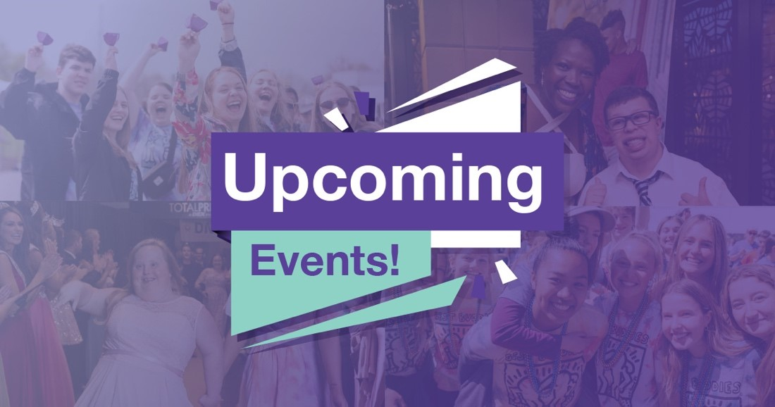
Month Day (ex: May 8)  City, State | Event Name | See details url link
Month Day (ex: May 8)  City, State | Event Name | See details url link
Month Day (ex: May 8)  City, State) | Event Name | See details url link

(Button Text = ”View All Events“ | Link = https://www.bestbuddies.org/yourstate/events )
