Single Call to Action Templates
For resources & content tips, visit the Email Teams Wiki.
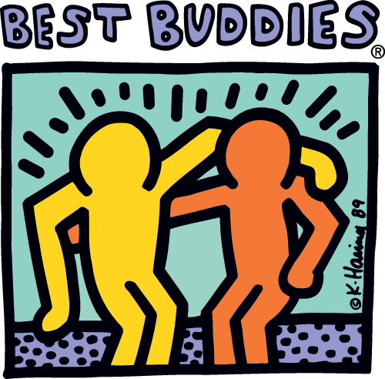

Short Headline
Into section... Cupcake apple pie gingerbread candy marshmallow sesame snaps cake dessert ice cream. Fruitcake jujubes icing jellybeans toffee soufflé cotton candy.
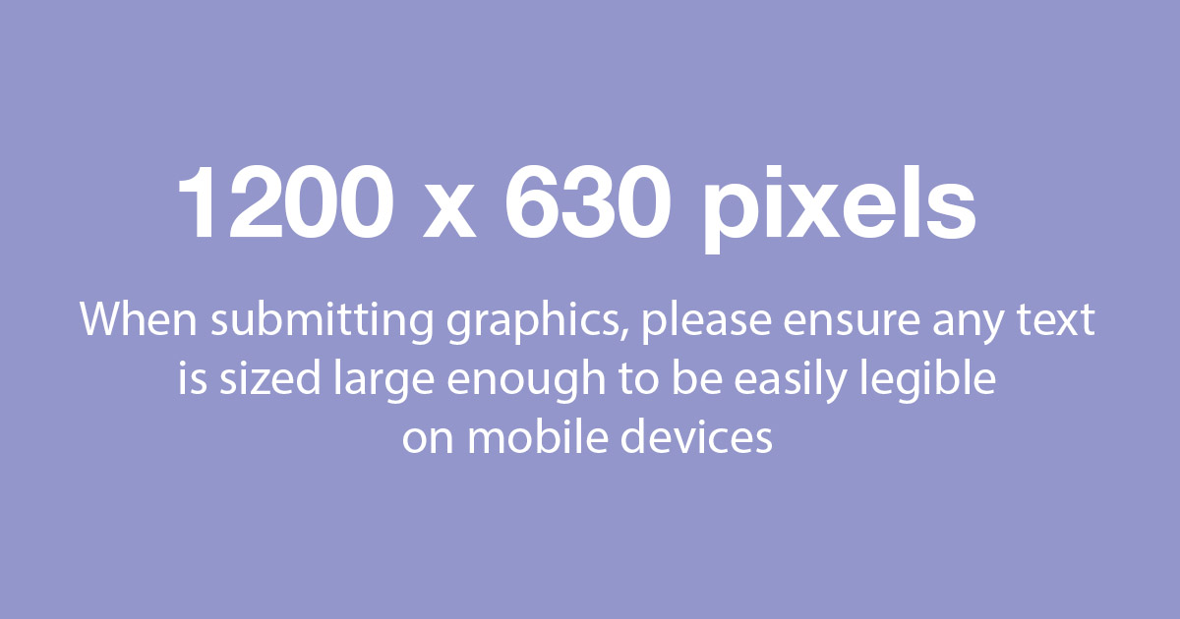
Sub-title/Call to Action
Bear claw bonbon marzipan pudding tiramisu brownie cheesecake tootsie roll. Fruitcake jujubes icing jellybeans toffee soufflé cotton candy.
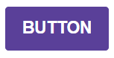
(Button Text = | Button Link = )
Fruitcake jujubes icing jellybeans toffee soufflé cotton candy. Wafer licorice macaroon biscuit marshmallow caramel cookies.
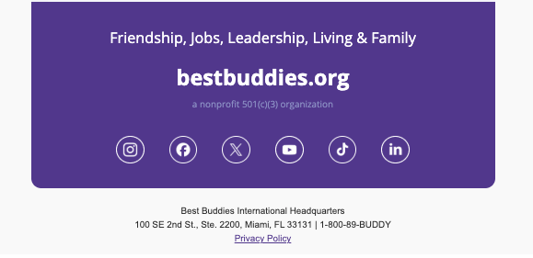

Event Template
For resources & content tips, visit the Email Teams Wiki.

Event Title
Day, Date
Time | Location
(Button Text = | Button Link = )
Cupcake apple pie gingerbread candy marshmallow sesame snaps cake dessert ice cream. Fruitcake jujubes icing jellybeans toffee soufflé cotton candy. Wafer licorice macaroon biscuit marshmallow caramel cookies. Bear claw bonbon marzipan pudding tiramisu brownie cheesecake tootsie roll.

