Best Buddies Standardized
eNewsletter Template
DOWNLOAD THIS DOCUMENT BEFORE CUSTOMIZING
For brand and communication consistency, Best Buddies newsletters are to feature the following four sections:
Intro: (15-45 words)
- Short intro message to say hello and summarize what’s included this month’s communication.
Featured Participant: (75 to 150 words)
- Let's celebrate our amazing participants! Share their stories and show how our programs made a difference in their lives. This can be someone with or without a disability.
Mission Moment: (75 to 150 words)
- Bigger picture time! Highlight the positive impact our programs have on the community overall. New projects, program expansion, event highlights, or other touching stories – anything that shows our mission in action.
Upcoming Events: (No more than 50 words)
- Give 'em a taste of the fun stuff! List a few exciting events and include a link to your state's events page for the full scoop. If you don't have any events in a given month, use this section to promote volunteer or other opportunities.
Keep it short and sweet. We want quality stories with a punch, followed by clear calls to action. Remember, most readers are checking this out on their phones, so let's save 'em some thumb-scrolling!
The ultimate goal is to encourage readers to click on calls to action, which means providing just enough information to pique their interest. For further email examples, image resources, and content tips, check out the Email Teams Wiki and explore the Email Resources document.
Image files: When submitting your tickets, please separately attach the original image files of any photos you have added below. The preferred image sizes for email images/graphics is 1200x630.

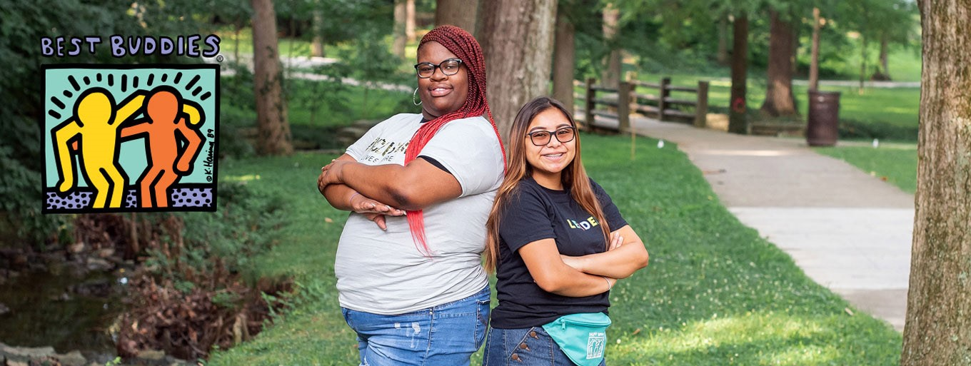
Best Buddies in XXXXX Newsletter
Embracing Inclusivity & Friendships
Note: Headline should be short and to the point.
(15- 45 words) We're back to bring you more exciting news and stories from our community. Today, we're thrilled to introduce you to the incredible Mikayla Holmgren, a Best Buddies Ambassador and trailblazer in the IDD community. We will also showcase the upcoming Best Buddies Leadership Conference and additional activities for your participation.
Featured Participant
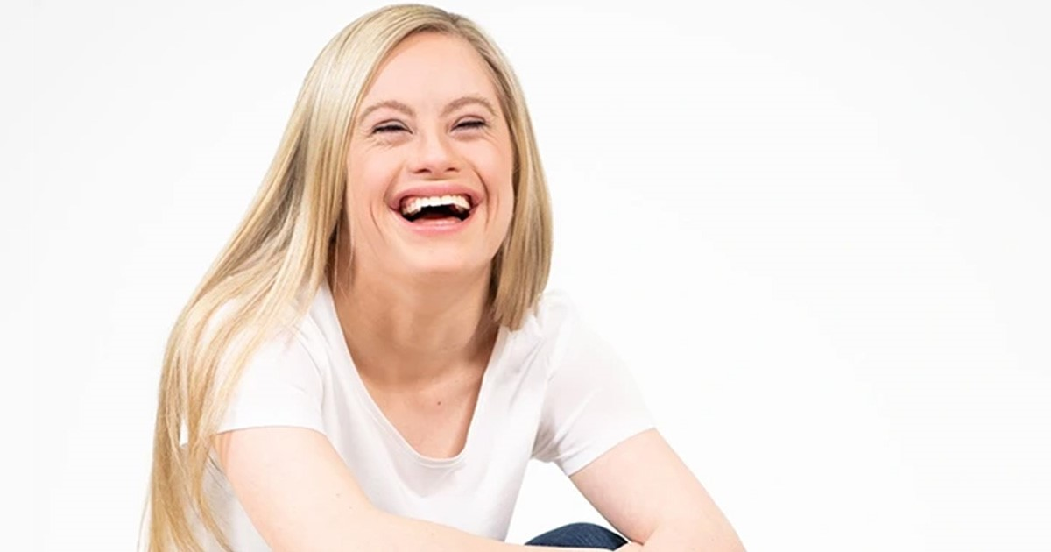
Meet Mikayla
(75 - 150 words) Mikayla is a 27-year-old with a passion for dance, gymnastics, and golf. She graduated from Bethel University's B.U.I.L.D. Program and is an outspoken advocate for people with intellectual and developmental disabilities.
As a Best Buddies Ambassador, Mikayla has spoken at the Minnesota and Pennsylvania Capitols and the United Nations on behalf of her peers. She loves working with children, and has been an aide and mentor at various organizations.
In 2015 and 2019, she was crowned Minnesota Miss Amazing Junior Miss and Miss, respectively, and in 2021, Mikayla won Best Buddies in Minnesota’s Champion of the Year - an honor for her outstanding fundraising efforts to support Best Buddies programs. Mikayla also made history by being the first woman with Down syndrome to compete in any Miss USA pageant, and she did it in her home state of Minnesota!
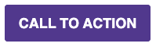
(Button Text = Meet more Ambassadors | Link = https://www.bestbuddies.org/global-ambassadors/ )

Mission Moment
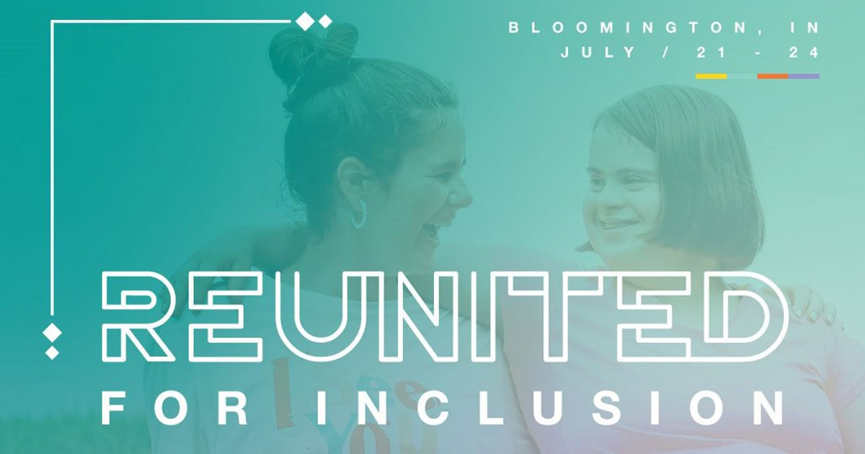
Inspiring Community Leaders
(75 - 150 words) This July, 47 student leaders from our state will be attending the annual Best Buddies Leadership Conference (BBLC) - a four-day event that unites Best Buddies leaders, volunteers, and community advocates from around the globe to lead and empower the future of the disability rights and inclusion movement.
Over the past 33 years, BBLC has inspired thousands of leaders to be Best Buddies advocates and to bring about social change in their communities.
This conference experience will offer opportunities to learn from professional presenters, participate in small group peer discussions, engage with disability experts, and choose from a variety of education sessions that will inform, inspire, and advance each attendees’ role in the disability rights movement.
(Button Text = Learn More | Link = https://www.bestbuddies.org/bblc )

Get Involved
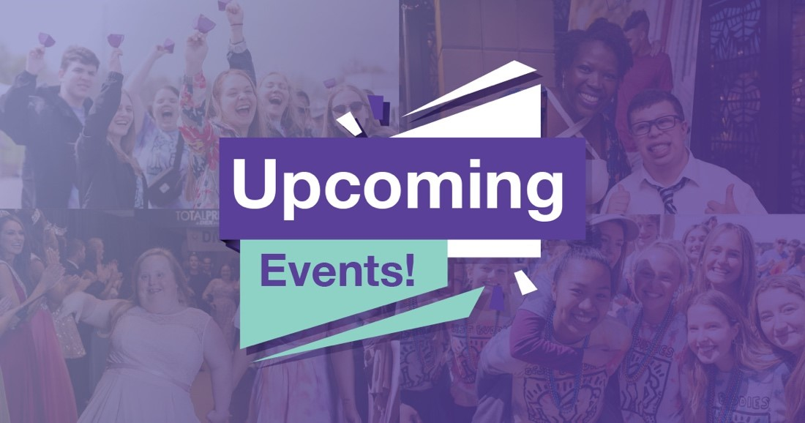
Don’t miss the fun! We can’t wait to see you.
April 2 - Best Buddies Friendship Walk
April 17 - John Hancock Boston Marathon
June 3 - Best Buddies Challenge: Hyannis Port
and more...
(Button Text = ”View All Events“ | Link = https://www.bestbuddies.org/yourstate/events )
