Zoom - Call into a Zoom Meeting
Last Updated: 07/11/2019
Back to: Zoom - Web Conferencing
Layout:
One Column
Two Column

This tutorial is operating system independent.

OVERVIEW
Zoom has functionality allow participants to join a meeting via telephone audio.
To join a Zoom meeting via audio conference (telephone) the meeting will need to be started and the host or participant needs to provide the meeting ID.
The meeting ID can be found at the top of the Zoom window:
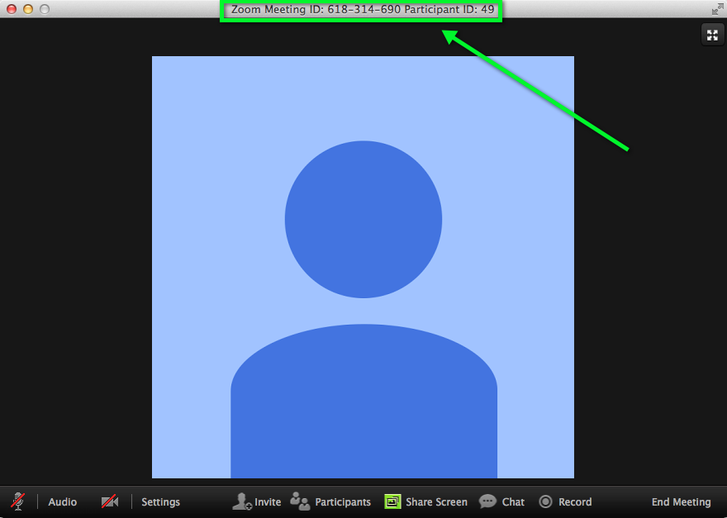

Step 1
Audio conferencing participant will need to call:
(415) 762-9988 or (646) 568-7788
AND follow the verbal instructions.

Step 2
Enter the meeting ID you wish to join followed by the # key.

Step 3
You will be asked to enter your participant ID.
If you do not know your participant ID, simply press the # key

Step 4
You have now joined the Zoom meeting.

