Best Buddies: Virtual Ambassador Training
Best Practices for Implementing a Virtual Ambassador Training

Staff / Volunteer Involvement
- 1 Host to “run” the technical side of the program; this Host can monitor the chat room comments/ questions from Ambassadors, monitor the mute features of attendees (as needed). move the slide presentation along, navigate between video links, and monitor time per topic.
- 1 Instructor to lead discussions and to deliver the content; allow the Host to worry about all the technical pieces of the training. The Instructor should focus on delivering the content and meeting individual Ambassador’s needs during each session.
- Speech Coaches (equal to number of students) to engage with students, provide feedback on speech outlines, drafts and presentation skills; Speech Coaches can attend all sessions or can be asked to assist with Days 3 & 4 only, as available

Ambassador Participation & Class Size

Virtual classroom space is typically 100 or more, however groups larger than 25 are more challenging to manage in such a format. The following includes some tips
- Group of 6-8 Ambassadors allow for equal engagement throughout each session
- Larger groups of Ambassadors will require the Host to utilize the Breakout Room feature of ZOOM (or similar online platform) to offer small group discussions options through the
Using ZOOM – a Group Video Conferencing Program

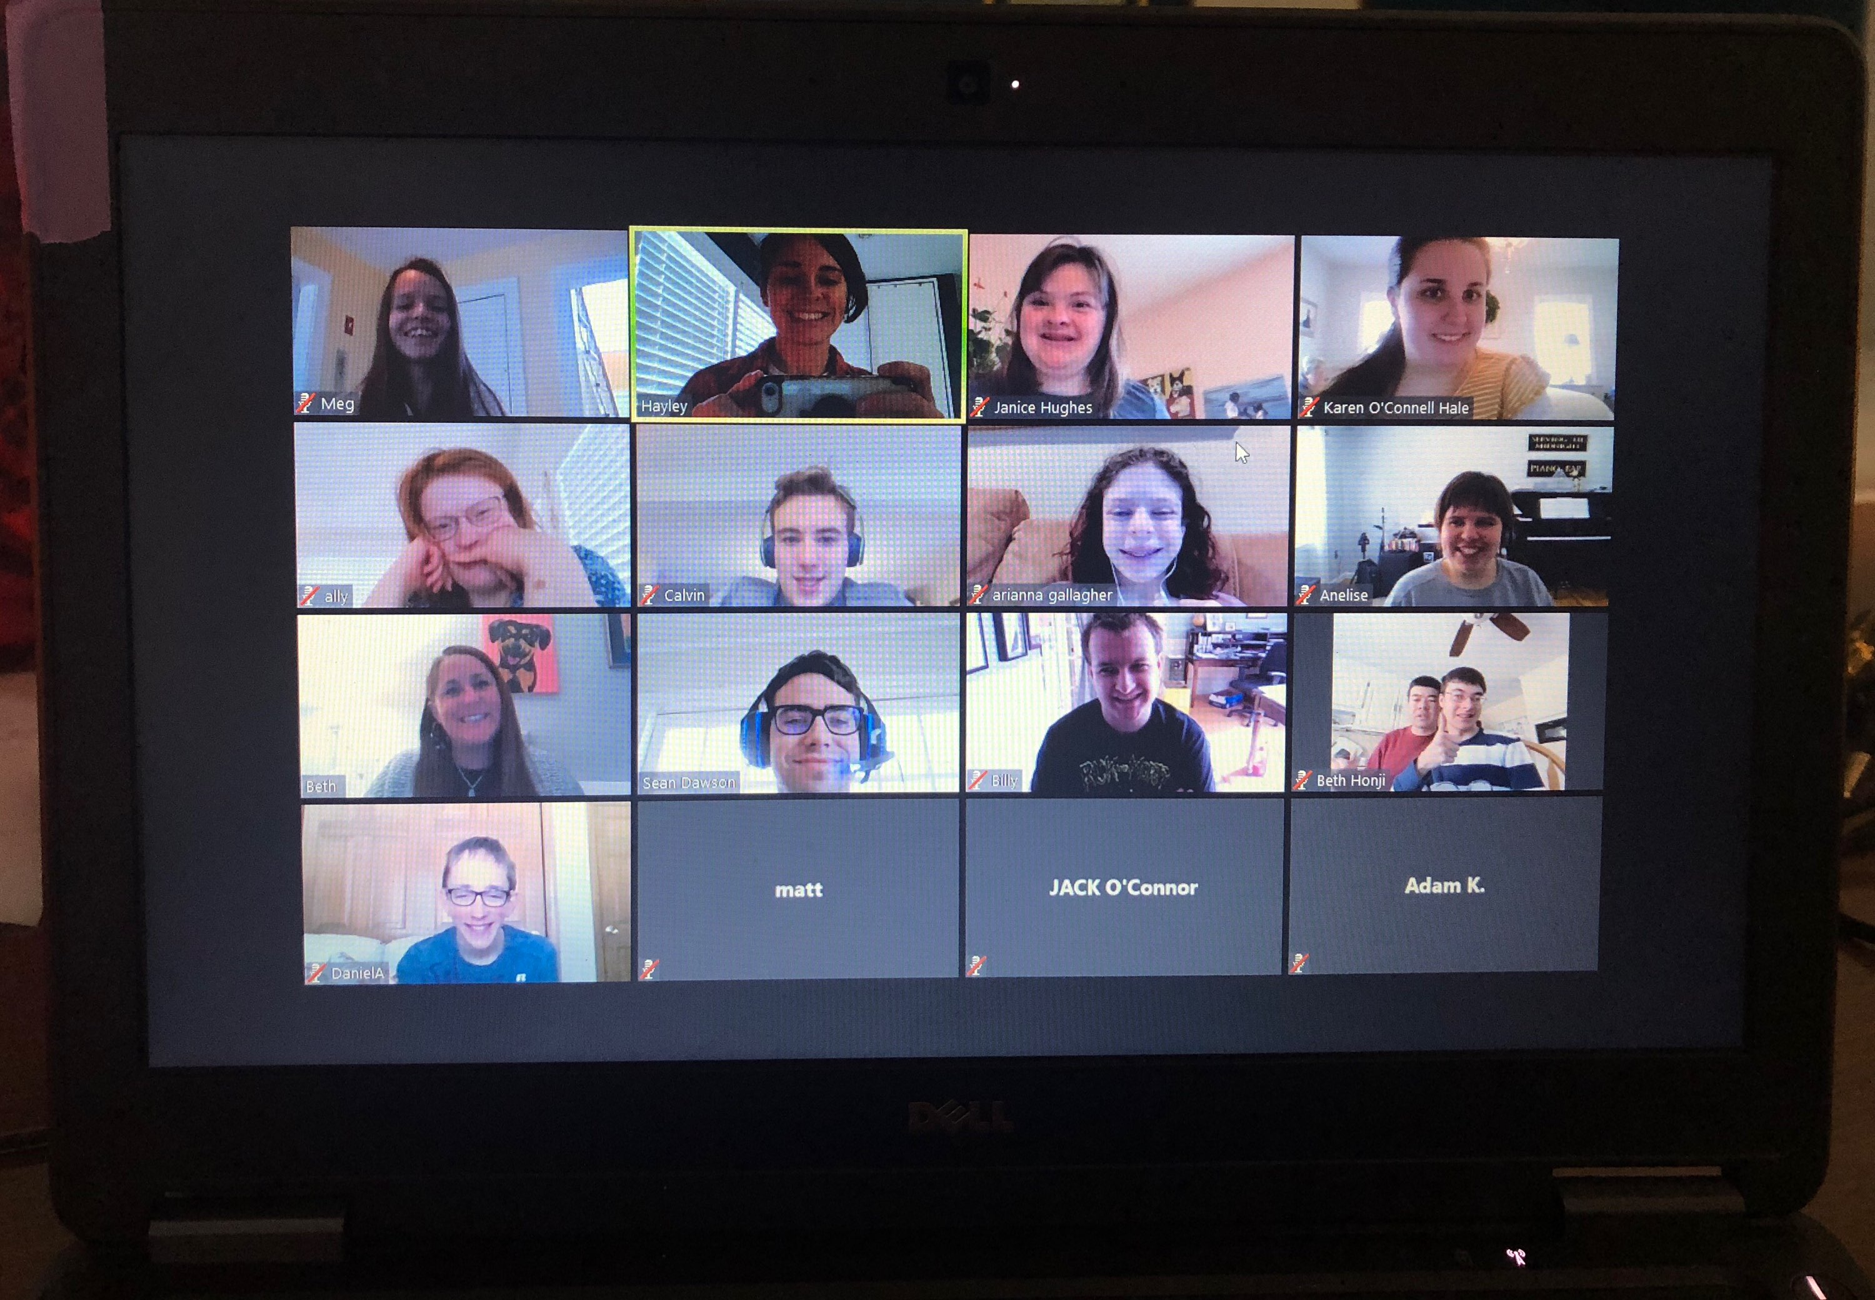
ZOOM does offer a FREE platform for general use, however calls are limited to 40 minutes per session. Paid accounts in varying levels allow for unlimited time and various numbers of participants. Join via: zoom.us
Online ZOOM Tutorial

It is recommended that you visit the site and learn how to use the host tools: Zoom Meeting Instruction Overview
*pdf attached for quick reference during session

ZOOM does offers attendees the ability to connect with video options or without. Some Ambassadors may prefer to log in WITHOUT video engagement to start – that is ok! Attendees can control video and audio controls to ensure accessibilities for all levels of comfort.

Invite Your Class to Your Zoom Webinar

Tips for Settings for Your Class:
- You must be on a registered account
- Attendees can join without signing up for a zoom. They can just join a class.
- Mute all participants upon entering the room.
- Turn camera Off upon entering
- Enable waiting room this way students will be prompted to wait until you open the meeting.
- Virtual Background should be used
  - If your computer supports the use of virtual backgrounds, you can use the Best Buddies Logo (black & white is less distracting) or a subtle non-distracting background. Photos may be uploaded but must be done prior to class. *Video Tab or Settings
  - If your computer does not support virtual backgrounds, be sure to have a non-distracting background.
Responsibilities of a Host on ZOOM:
The host has control of the Zoom settings and features. The Host:
- Signs into the Zoom Account, which invited the participants.
- Should “record” the class. You can download these files from ZOOM, upload them to YouTube, etc.
- Is responsible for control of the screen, waiting room, PowerPoint, assigning classrooms
- Able to lock the class once it begins so no one will enter and interrupt
- Managing classrooms as well as fielding questions for participants
- Is visible to participants and should be introduced as a co-instructor
- Can be used to make notes on the whiteboard during instruction
- Able to “Control Participants” via the tab at the bottom
TIPS for the Host:
- Be sure to be in a quiet room
- Do not use the Bluetooth option for earphones, as this might make your videos play without sound.
- Be aware if anyone else is scheduled for room,, if sharing a ZOOM account with other staff. This can be checked on Schedule Tab prior to class.
Responsibilities of the Instructor on ZOOM
- Runs the class following the facilitation notes
- Signs into their own Zoom account. *Paid accounts may allow Co-Host Selection.
- Instructing Class and primary speaker
- Greeting and speaking to participants *note that you can’t always see all participant windows. Watch number of participants at the bottom of screen to make sure all are there.
- Give a brief review of rules of class (mute/unmute, video, hand-raising & emotions tabs)
- Communicating with host when necessary
- Able to make notes on whiteboard
- Time management so class stays within scheduled time, especially if another staff is scheduled to use the same ZOOM Room following your session(s)

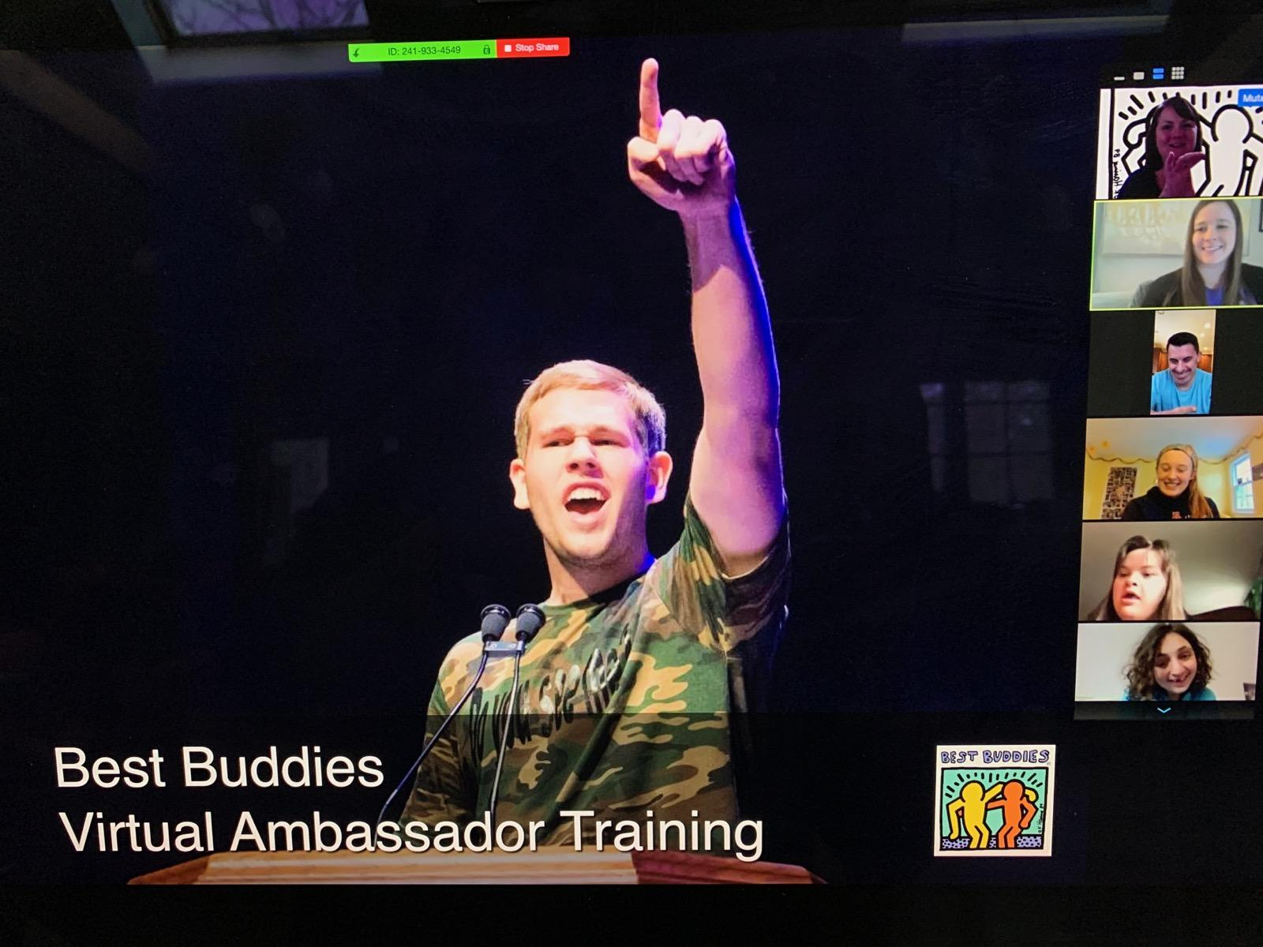
Extra ZOOM Features recommended in these Training Sessions
Screen Share: Host is able to screen share. While screen is shared, participants can still see each other in small windows. Host should upload all screen shares to your desktop and close all personal items while class is in session.
Whiteboard: Upload on Shared Screen, various features for class. Host should document, according to Instructors lead.
Breakout Rooms:
When students are ready to do an exercise with their coach, the Host will set up the breakout rooms to assign, Speech Coaches to Students. When indicated by Instructor, click Open Rooms. See the ZOOM Tutorial guide for more detail how to utilize the Breakout Room feature (shown below).

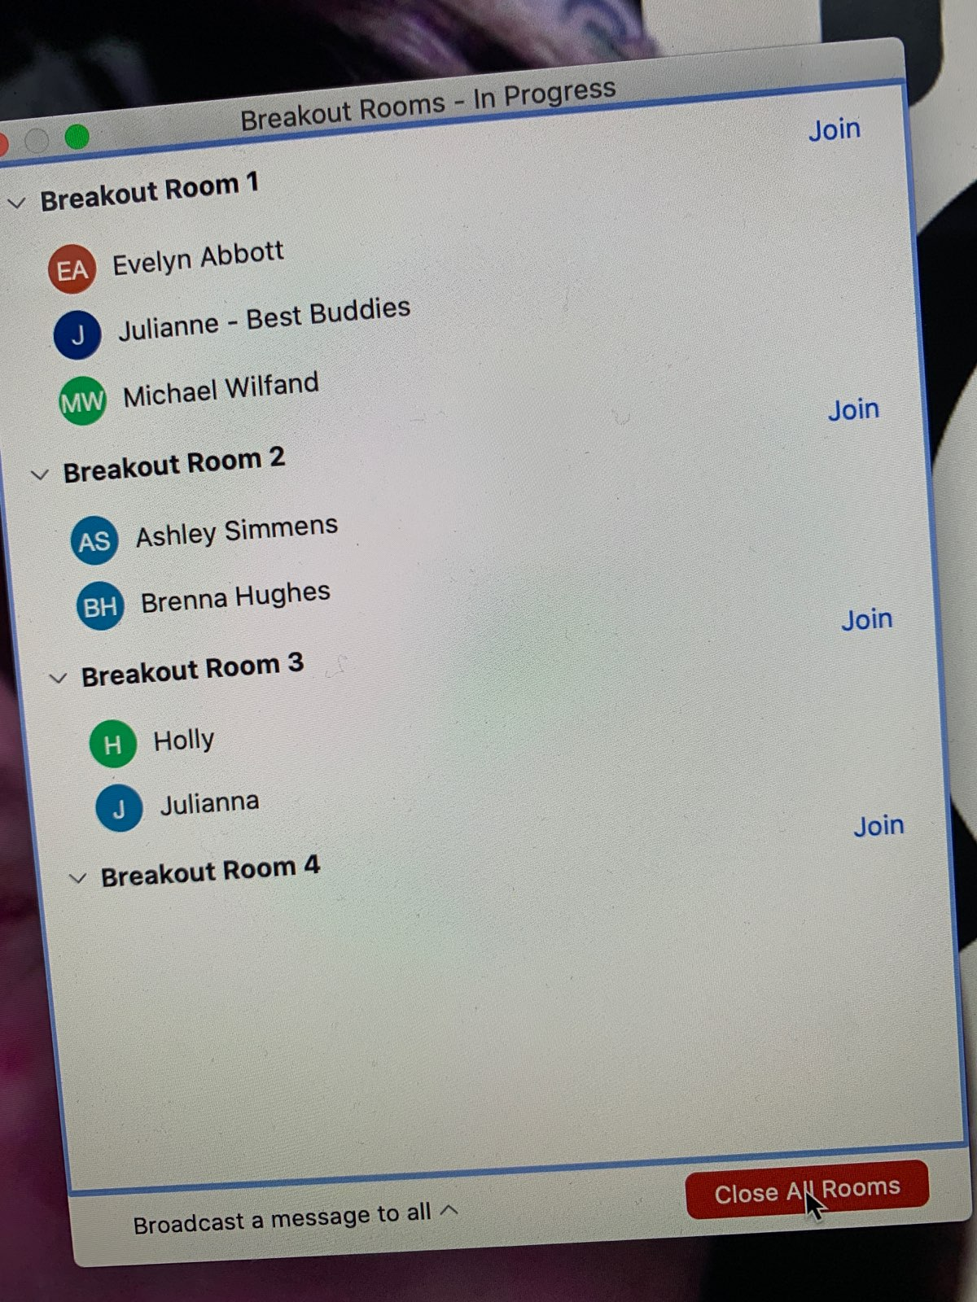

The Instructor can be a Speech Coach and assigned to a Breakout Room with students, however a Host cannot as they cannot be assigned to a room. If you have enough Coaches and Students assigned, this is a good time for Host and Instructor to chat about how it is going and plan ahead in the main room.
Each Room will then split off and Host should wait, and monitor.

If a room needs to ask a question, they can click a button and invite the Host in to assist.

There should be a time limit.

Host can send typed messages to the group. (I.e., 5 min warning, etc.)

When all rooms have returned to the Main Meeting, Instructor resumes.

Best Buddies Virtual Introductory Ambassador Training

Objective: To provide students with the tools, training, language and understanding on how to share their story, over the web, via an elevator pitch and/or a full beginner speech.
Goal: Students will leave with the ability to communicate their story and advocate for themselves.
Materials: Access to a video conference platform – ZOOM is the recommended format noted throughout the lesson, however other options work, too; Virtual Ambassador Training PPT; Internet access; access to a computer, iPad or other device with email and video conferencing capacity (preferred); paper & writing utensils; access to a printer, as able; 30 Second Elevator Pitch Worksheet, This is Me! Pitch Worksheet(s); Mission Statement Worksheet; Writing Your Speech Worksheet;
Time: 1 hour session recommended, although you may need to allocate a bit more time if Ambassadors have challenges with technology. You may find it helpful to host a practice round before the 1st session, so students can learn how to access ZOOM, mute/ unmute, raise their hands, etc.
Reminder: Be sure to record each session – you’ll be able to download these files, upload them to YouTube, email them out to participants, etc after each session concludes

Virtual Introductory Ambassador Training Day 1 Facilitation Notes

Welcome & Introductions (5 minutes) – ask each student/ staff to share name, school or town they reside, Best Buddies involvement (if any)

Icebreaker: recommended making this quick share questions that will allow Ambassador’s to practice their presentation skills

Getting Around ZOOM (5 minute) – share an overview of how to use the ZOOM Platform. Be sure to explain where the chat feature is located, how to raise your hand should you have a question, how to unmute/ mute yourself, etc.

Recap training | Purpose (5 minutes)
- All students will learn what it means to be a self-advocate then will write a speech on sharing their story, how the BB mission has impacted their lives and how to present their speech publically.
- This session will review what it means to be an ambassador, what a mission statement is, how to develop their own mission statement in relation to their story, and the components on how to write a speech.
  - Even if ambassadors are not matched in a program, they can still learn about what we do as an organization and how we operate worldwide
Goals and Rules (10 minutes)
- Ask ambassadors what their goals are for the training. What do they hope to accomplish?
  - Turn this into a brief discussion
  - Write down some of the goals using the ZOOM whiteboard feature
- In order to reach these goals, what rules need to be set? Come up with some, as a group

Try your best - Ask for help - Respectful and encouraging language - Have fun!

What is Self-Advocacy?

- Using the white board feature on ZOOM, ask students to brainstorm responses to the following question: Have students brainstorm what they think Self-Advocacy means?
- Show students 1 or more of the the following BB Ambassador video (s); students take notes about their observations of each video. After, ask students to share their observations (note examples on ZOOM white board)
- Jack 1: https://youtu.be/iI0lmpvElGY
- Jack 2: https://www.youtube.com/watch?v=Jz1I6tO1uMc
- Hector: https://youtu.be/CkEihVWK0bI
- Review/define Self-Advocacy (Source: https://www.wrightslaw.com/info/self.advocacy.htm):
- learning how to speak up for yourself
- making your own decisions about your own life
- learning how to get information so that you can understand things that are of interest to you
- finding out who will support you in your journey
- knowing your rights and responsibilities
- problem solving, listening and learning, reaching out to others when you need help and friendship
- and learning about self-determination
- Have students help make a list and/or share when they had to self- advocate on the ZOOM whiteboard. Prompt students to think about times they had to advocate at home? At school? At work?
- Have students think about their own Self-Advocacy Goal for the future; students will be asked to email a goal as part of Day 1’s follow up activities.

30 Second Elevator Pitch
- Explain that first impressions matter; a 15-30 second conversation can make a lasting impression.
- Play the video - The Job Search: Elevator Pitch https://youtu.be/wCky2qKTtfQ
- Ask students to share their observations of the video.
- Think about what you would include in your Elevator Pitch. This will be completed for “homework” after the Day 1 session concludes.

Follow Up Activities – Day 1

Ask students to email the following completed activities before the start of the next session, as able.
- What is your Self-Advocacy Goal? Try to create 1-3 goals you have to help improve your self-advocacy skills.
- Distribute the 30 Second Elevator Pitch Worksheet to review the parts of an elevator pitch. Students will then work on creating their own pitch – optional worksheets include 30 Second Elevator Pitch or variety of This is Me! Pitch worksheets (including a variety of levels of prompts)
- Students will be asked to present their This is Me! Pitch during the next session.

Virtual Introductory Ambassador Training Day 2 Facilitation Notes

Welcome & Recap Training Objectives
- All students will learn what it means to be a self-advocate then will write a speech on sharing their story, how the BB mission has impacted their lives and how to present their speech publically.
- This session will review what it means to be an ambassador, what a mission statement is, how to develop their own mission statement in relation to their story, and the components on how to write a speech.
  - Even if ambassadors are not matched in a program, they can still learn about what we do as an organization and how we operate worldwide
Review (as needed) Getting Around ZOOM (5 minute) – share an overview of how to use the ZOOM Platform. Be sure to explain where the chat feature is located, how to raise your hand should you have a question, how to unmute/ mute yourself, etc.

Icebreaker - recommended making this quick share questions that will allow Ambassador’s to practice their presentation skills

Share Your Elevator Pitch – ask students to share the This is Me! Elevator Pitches they drafted after session #1. Staff should emphasize how students can use this pitch when they meet new people, attend networking events, attend college campus tours, or job interviews.

What is an Ambassador? (15 minutes – using powerpoint presentation)
- Have students watch Hector’s speech: https://youtu.be/CkEihVWK0bI
  - Ask students to share feedback about his presentation skills, message, etc.
- An ambassador is the face of Best Buddies –what does that mean?
- Let’s Brainstorm: Use the ZOOM whiteboard feature to take notes about ideas students brainstorm.
  - What does being an ambassador mean?
  - What are the qualities of an ambassador?
  - What responsibilities do ambassadors have? What role does an ambassador play within and outside of BB?
  - Why are you interested in being an ambassador?
- Best Buddies Ambassadors help us spread our mission – at our events, important meetings, through your own personal network and beyond. Your voice matters and helps us share our mission with others!

Why Share Your Story?
- Why is it important to be able to tell others about yourself, your experiences, or your hopes?
- Discuss the following questions, as a group; use ZOOM white board to take notes, as able.
  - What do you gain from sharing with others?
  - What do others gain from hearing you share?
- Remind students that their elevator pitch is just the beginning – this will help them share their Best Buddies story in other settings.

Finding Your Mission

Begin by asking what the ambassadors believe a mission is
- NEXT SLIDE – provide a definition
  - Mission –“a strongly felt aim, ambition, or calling”
- Ask ambassadors to explain what they believe this to mean to them, to their community, etc.
Writing Your Own Mission Statement (25 minutes)
- Talk about individuals with different careers; ask ambassadors to point out specific individuals, defining their mission. Also talk about the different non-profit organization in the slides and their mission statements.
  - Ex: Doctor - to save lives or keep people healthy,
  - Ex: Police - to keep people safe,
  - Ex: Teacher - to help people learn, etc.
- Discussion: how does the mission of their work help these people?
  - It helps keep them on track; it helps them identify if they are doing a good job; it informs people around them what they do and what they can help with
- What is YOUR Mission?
  - What is your “calling, aim, ambition”
  - What do you hope to accomplish in your community, in your lifetime?
  - How can knowing your mission keep you on track in meeting your goals?
  - How can knowing your mission inform the community of what you have to offer, what you can do for others, what impact you can have?
  - How can this information guide you and help make sure your goals are met?
  - How will you know when your mission is being met?
- What is the main piece of information that you want the audience to learn about you?

Follow Up Activities – Day 2

- Remind students to watch their email for follow up directions.
- Have ambassadors use the Mission Statement worksheet to create their personal mission statement.
- They should be prepared to share their mission statements with the group during session #3
- Remind them that they are encouraged to incorporate these into their speech in addition to their personal story they identified earlier.

Virtual Introductory Ambassador Training Day 3 Facilitation Notes

Welcome & Recap Training Objectives
- All students will learn what it means to be a self-advocate then will write a speech on sharing their story, how the BB mission has impacted their lives and how to present their speech publically.
- This session will review what it means to be an ambassador, what a mission statement is, how to develop their own mission statement in relation to their story, and the components on how to write a speech.
  - Even if ambassadors are not matched in a program, they can still learn about what we do as an organization and how we operate worldwide
Review (as needed) Getting Around ZOOM (5 minute) – share an overview of how to use the ZOOM Platform. Be sure to explain where the chat feature is located, how to raise your hand should you have a question, how to unmute/ mute yourself, etc.

How to Write a Speech: (15 minutes)
- There are three main parts to every speech: intro, body, and conclusion
  - How do we know this? Do we see this in books and in movies?
  - This helps keep the story going; helps people know why they should listen, what they will learn, and how this will teach/help/impact them
- Review slides about each section
Writing the Speech:
- Display the Writing Your Speech worksheet on screen share; ask students to have a copy of the worksheet on hand, have other paper available, and/or to be prepared to take notes on their computers/ devises.
- Students will be writing their speeches independently after the webinar session. However, use this time to discuss strategies to get them started, walk them through the Writing Your Speech worksheet – prompting them to brainstorm their responses to each question with you, then address additional questions as needed
Follow Up Activities Day 3:
- Ask students to continue to work on the Writing Your Speech worksheet, if needed and it’s helpful.
- Otherwise, students should begin to write their speeches independently. Students should be prepared to email and “present” their opening paragraph on Day 4.

Optional Implementation Strategies:
- If working with a small group, they may be prepared to present their entire speech on Day 4. Use your best judgement – if students are ready, and it won’t be too overwhelming to hear from every student on Day 4, then ask them to draft their entire speech and be prepared to present.
- If working with a large group or group of students who need increased support, implement as noted above. Staff can review presentation skills, then students can share a piece of their speech on Day 4. Best Practice – students should then be asked to continue to work on their speeches, then they will be paired 1:1 with a BB staff or volunteer to meet via webinar to review their drafts, practice presenting, etc. More details in Day 4 Facilitation Notes.
Virtual Introductory Ambassador Training Day 4 Facilitation Notes

Welcome & Recap Training Objectives
- All students will learn what it means to be a self-advocate then will write a speech on sharing their story, how the BB mission has impacted their lives and how to present their speech publically.
- This session will review what it means to be an ambassador, what a mission statement is, how to develop their own mission statement in relation to their story, and the components on how to write a speech.
  - Even if ambassadors are not matched in a program, they can still learn about what we do as an organization and how we operate worldwide
Review (as needed) Getting Around ZOOM (5 minute) – share an overview of how to use the ZOOM Platform. Be sure to explain where the chat feature is located, how to raise your hand should you have a question, how to unmute/ mute yourself, etc.

Icebreaker: as time allows

Review Writing the Speech: (5 minutes)
- Ask students to gather their Writing Your Speech worksheet, MY STORY draft speech, & writing utensils as needed
- Quickly review the parts of a speech; ask students to look at their own speech as you review. Ask them to raise their hand if they’ve included each part as you proceed (Do you have an introduction? If you’ve written your conclusion, did you remember to thank the audience? etc)

Presenting a Speech: (5 minutes)
- Review skills that ambassadors should keep in mind while presenting
- Feel free to add to the list provided on the slide
Speech Presentations
- The goal should be to allow each ambassador the opportunity to share at least a portion of their speech with the entire group; optional implementation strategies include:
  - If a small group: ask each student to share their entire speech (as much as they have completed to date) with the group.
  - For groups of more than 6: ask each ambassador to share one part of their speech. You can alternate between asking for introductions, conclusions, etc. You can also use the Breakout Room feature on Zoom to allow ambassadors the opportunity to share their speeches in smaller groups.
- Continued work on speeches should continue; depending on group size and time allocated, you can collectively share suggestions for edits, additions, or modifications to speeches. Additionally, staff/ volunteers can use the Breakout Room feature on ZOOM to meet 1:1 or in small groups with students to continue work on individual speeches.

Closing: Last 10 minutes of the Session
- CONGRATULATIONS! It is important to celebrate the completion of these sessions. Be sure to throw on some music for a celebratory, virtual dance party. Give each other a round of applause. Be sure to take a group photo of your screen (serious shot… of course a funny shot, too!)
- Remind ambassadors that practice makes perfect
- Encourage them to look for opportunities where they can share their speech
  - Chapter meetings, with coworkers, with family/friends, etc.
- Remind them about any upcoming activities that they are encouraged to attend
- Thank speech coaches and ambassadors for attending!

Follow Up Activities – Day 4

Ambassadors should:
- Continue working on their speeches; be sure they email a copy to lead staff!
- Be sent the post-training survey

Staff should:
- Scheduled follow up 1:1 calls with each ambassador to review their final speeches. This can be done by phone, ZOOM, etc.
- Forward via email or mail Completion Certificates to each Ambassador
- Complete all Ambassador Training Tracking, as usual

THANK YOU for doing an amazing job implementing a Virtual Ambassador Program
And for keeping our mission moving forward.

